  Erin Savage  Principal | Lakewood High School  1400 54th Ave South  St. Petersburg, FL 33705  Phone: 727-893-2916  FAX: 727-893-1387 | Assistant Principals:  Tequena Akintonde  Cristina Calderon  Laura Mudd  Joseph Serra

The Mission of Lakewood High School is to create and nurture a foundation for learning and academic success where students take pride in their accomplishments and develop character traits, which have a positive impact on their education experience.

The Mission of the Lakewood High School AVID program is to close the Opportunity Gap by preparing all students for College and Career readiness with the goal of securing their success in a Global Society.

September 18, 2022
Greetings Spartans,
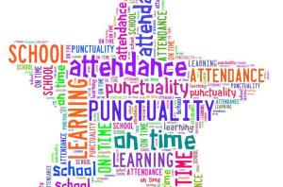
Punctuality and Attendance are crucial to your child’s success in school. Please make sure they get a good night’s sleep and are on time each day to school. Student hours are from 7:10 A.M. – 1:55 P.M.

KUDOS
Congratulations to Rebecca Borissova for being named one of 16,000 scholars as a National Merit Semi-Finalist! We are wishing her luck as she continues on her journey of becoming a Finalist.

Congratulations to the Varsity Football Team for defeating Pinellas Park High School last Friday night.

Coaches and Sponsors are encouraged to send accomplishments to Ms. Savage at savagee@pcsb.org

Start with Hello Week
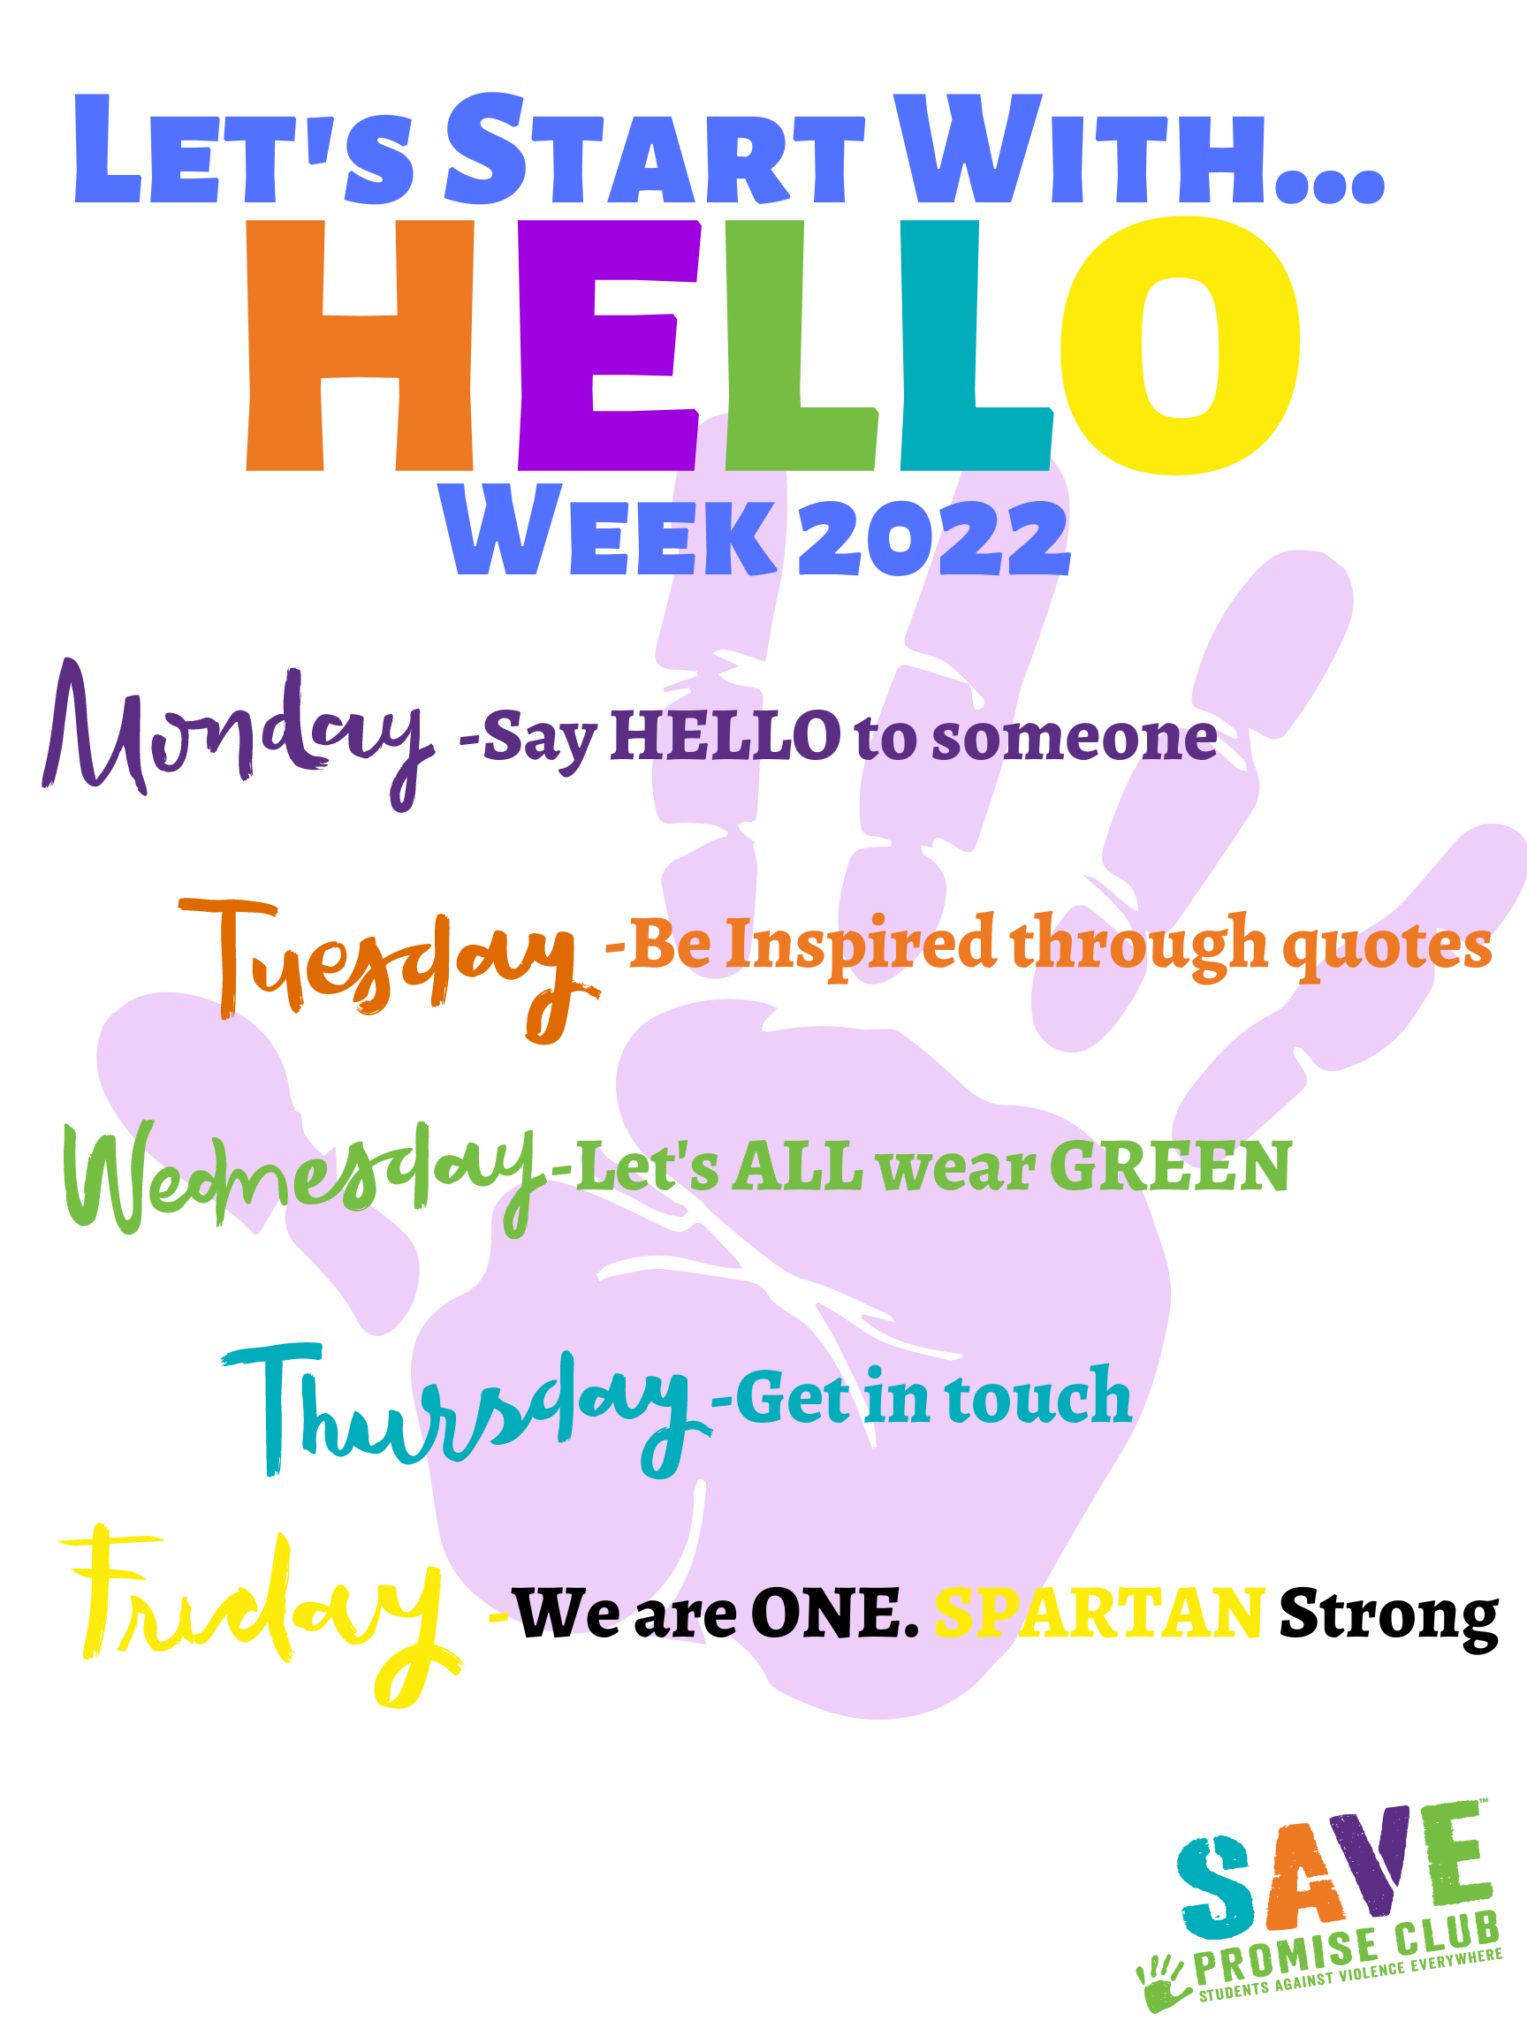
Walkers Rising Stars Competition
Attention Pinellas County high school junior and senior students of the arts. It’s time to apply for the Walker’s Rising Stars Scholarship Competition. The competition and awards show are administered and produced by the Pinellas Education Foundation in partnership with Pinellas County Schools and the deadline to apply is October 28 at midnight. There are 6 categories of the Walker’s Rising Stars program: Dance, Theatre, Instrumental Music, Vocal, Visual Arts, and Culinary. The Ryan Wells Foundation will present Rising Stars scholarships in the Culinary Arts category and application for the culinary competition should be made to them.

Application for the Walker’s Rising Stars performing and visual arts competition and the Walker’s Rising Stars updated guidelines are now available at: www.pinellaseducation.org/wrs

2022 Homecoming Week
- Homecoming Tickets go on sale on Monday, September 19th during lunch for $25 per ticket.
- Spirit Week is Monday 9/16 – Friday 9/30. The attire for the week is as follows. All attire must follow the Pinellas County Schools Dress Code.
  - Monday – Generation Day
    - Seniors – 2000’s
    - Juniors – 90’s
    - Sophomores – 80’s
    - Freshmen – 70’s
  - Tuesday – Hippie Day
  - Wednesday – “Anything but a Back Pack”
  - Thursday – Class Color Day
    - Freshmen - Yellow
    - Sophomores - Green
    - Juniors – Blue
    - Seniors – Red
    - Faculty - Purple
  - Friday – Black & Gold Day

Weekly Calendar
Monday 9/19  B-Day | Say Hello to Someone!  Golf@ Cove Cay
Tuesday 9/20  A-Day | Be Inspired Through Quotes!  Senior Parent Night @ 6:30 P.M. (Lakewood Auditorium)
Wednesday 9/21  B-Day | Let’s All Wear Green!  JV Football vs. Boca Ciega  Swimming vs. Boca Ciega
Thursday 9/22  A-Day | Get in Touch!  No Evening Events
Friday 9/23  B-Day | We are One- Spartan Strong!  Senior Assembly @ 9:15 A.M. (Lakewood Auditorium)  Varsity Football @ Atlanta Delray Beach
Saturday 9/24 | Enjoy Your Weekend!

If you have any questions, please feel free to contact the school at 727.893.2916.

